**laporan keikutsertaan dalam seminar internasional bertema**

**”Exploring Cloud Infrastructure Opportunities and Challenges”**

**13 mei 2024**

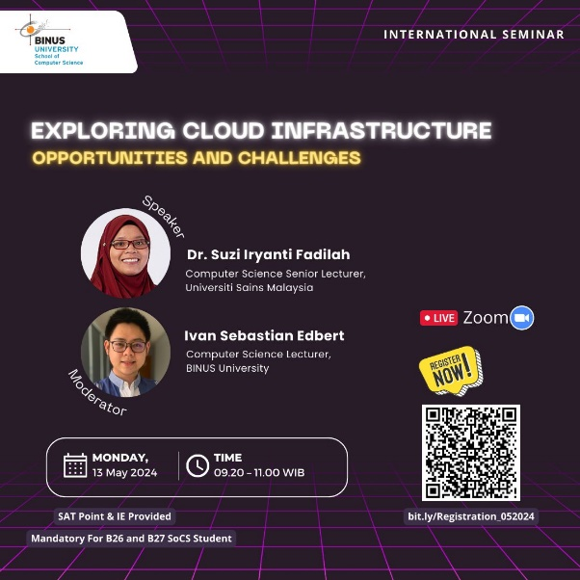

NIM : 2602183426

NAMA : Muhammad Hafizh Raihan Daniswara

MATA KULIAH : COMP6855004-Software Engineering

KELAS : LB20

RANGKUMAN ISI SEMINAR :

|  |  |
| --- | --- |
| **What is Cloud Computing**  Cloud computing is a model for delivering information technology services where resources are retrieved from the internet through web-based tools and applications, instead of owning physical hardware. It involves providing computing services—servers, storage, databases, networking, software, analytics, and intelligence—over the internet (the cloud) to offer faster innovation, flexible resources, and economies of scale.  **Service Models:**   * Infrastructure as a Service (IaaS): Provides virtualized computing resources over the internet. Examples include Amazon Web Services (AWS) and Microsoft Azure. * Platform as a Service (PaaS): Offers hardware and software tools over the internet, typically for application development. Examples include Google App Engine and Heroku. * Software as a Service (SaaS): Delivers software applications over the internet, on a subscription basis. Examples include Google Workspace and Microsoft 365.   **Deployment Models:**   * Public Cloud: Services are delivered over the public internet and shared across organizations. Examples include AWS, Google Cloud Platform (GCP), and Microsoft Azure. * Private Cloud: Services are maintained on a private network and used exclusively by a single organization. Examples include private data centers and dedicated enterprise clouds. * Hybrid Cloud: Combines public and private clouds, allowing data and applications to be shared between them. Examples include systems using both local servers and third-party public clouds.   **Benefits:**   * Cost Efficiency: Reduces the capital expense of buying hardware and software. * Scalability: Easily scale resources up or down to handle increases or decreases in demand. * Performance: Major cloud services run on a worldwide network of secure data centers, which are upgraded to the latest generation of fast and efficient computing hardware. * Speed and Agility: Vast amounts of computing resources can be provisioned in minutes, giving businesses a lot of flexibility and taking the pressure off capacity planning. * Security: Many cloud providers offer a set of policies, technologies, and controls that strengthen your security posture overall. | |
| 🗹 | Saya menyatakan bahwa rangkuman ini saya buat sendiri tanpa melakukan plagiarisme dari peserta lainnya dan bersedia menerima konsekwensi sesuai ketentuan yang berlaku di lingkungan Universitas Bina Nusantara jika ternyata terbukti telah terjadi plagiarisme. |

LAMPIRAN BUKTI KEHADIRAN :

|  |
| --- |
|  |